Bailey, Taylor 3/14/2018 18SP_F2 IST190 LINUX Essentials (W02)

Lab2

Lab2-3.2-12

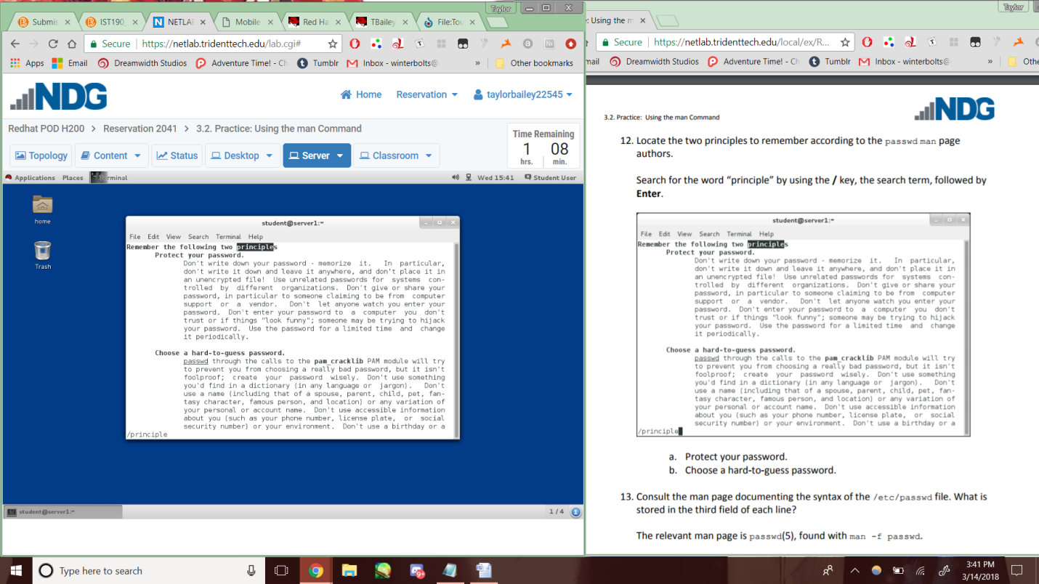

Lab2-3.4-14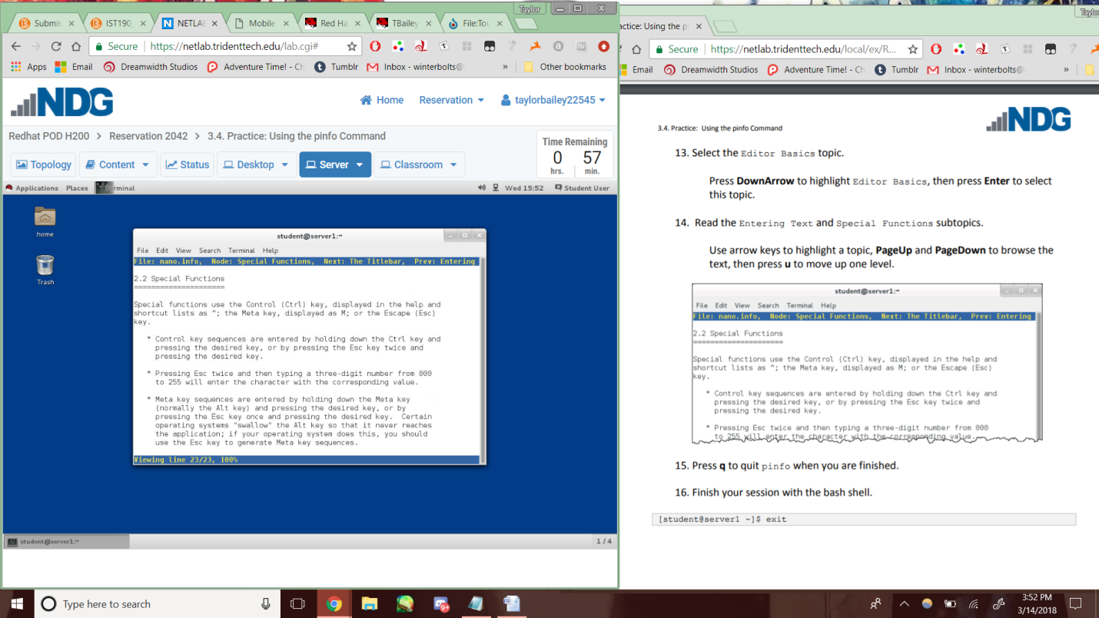

Lab2-3.6-9

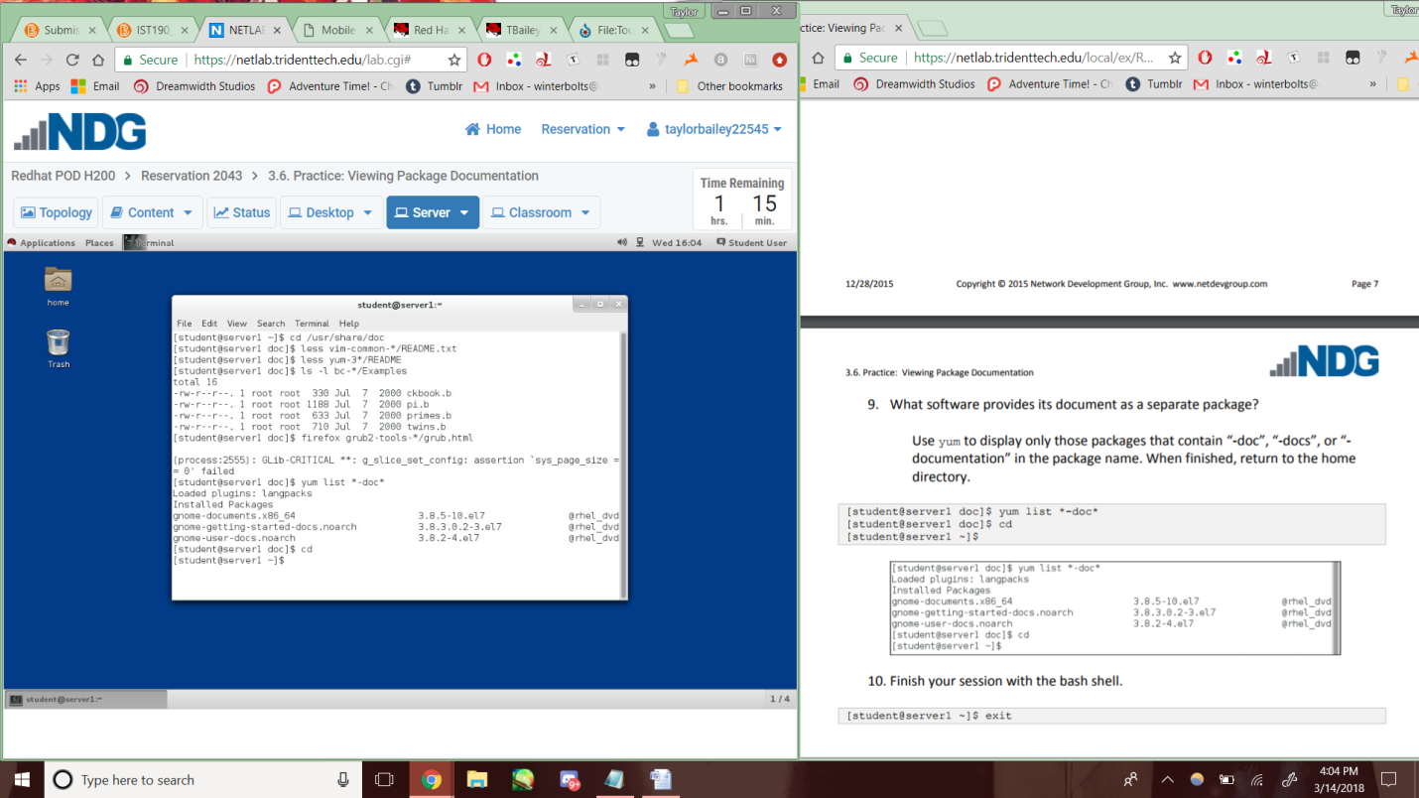

Lab2-3.8-8

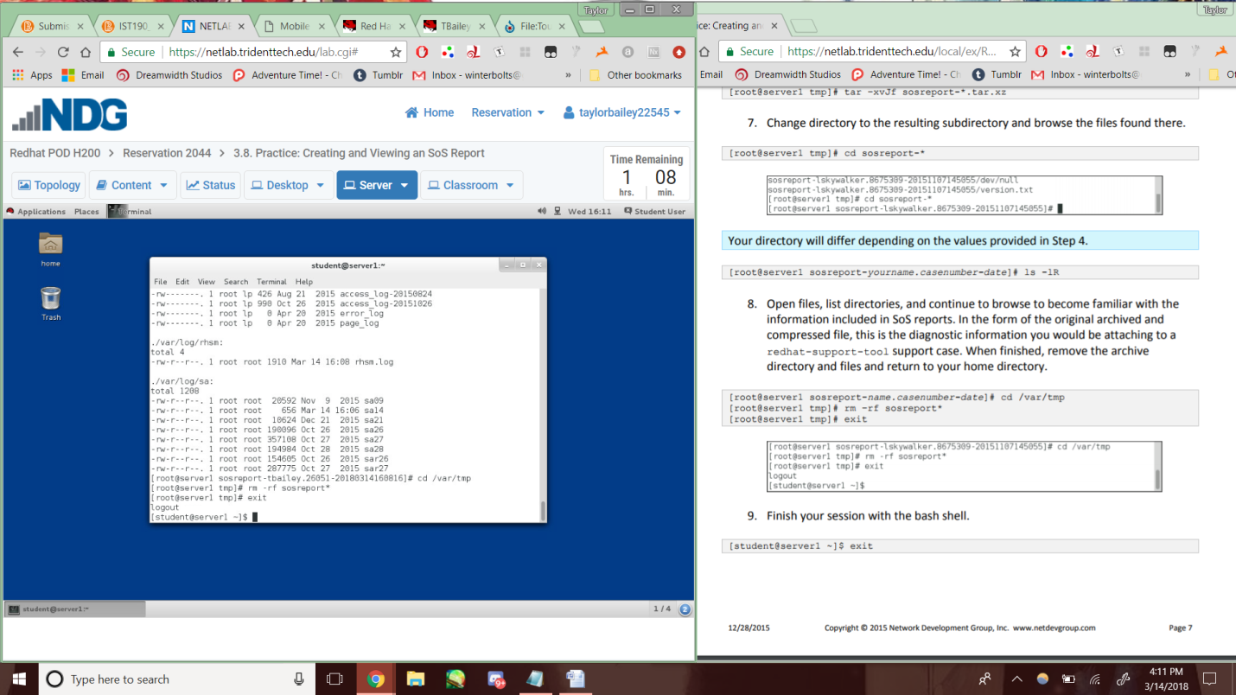

Lab2-3.9-11&12

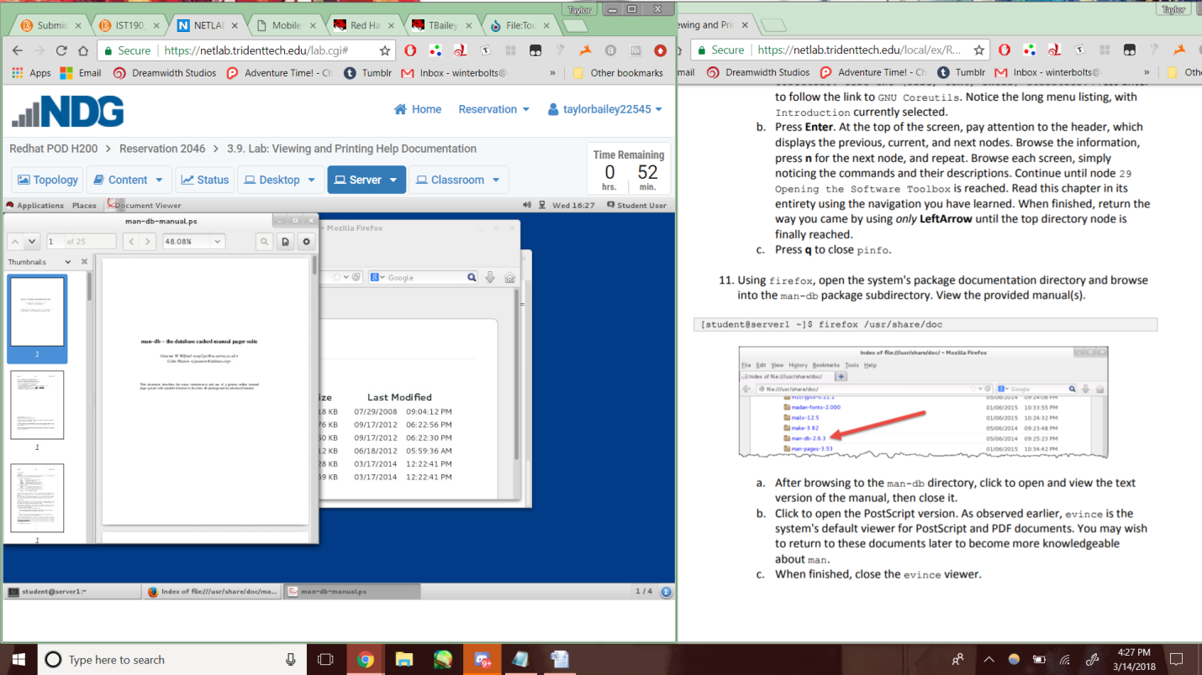

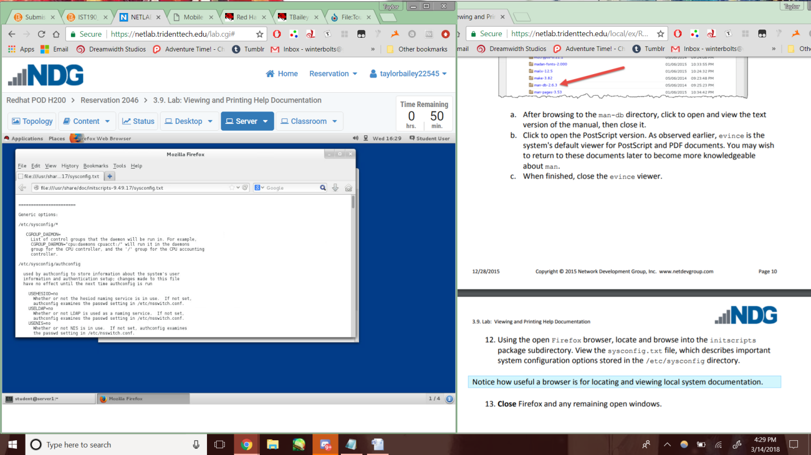

Lab2-4.4-7

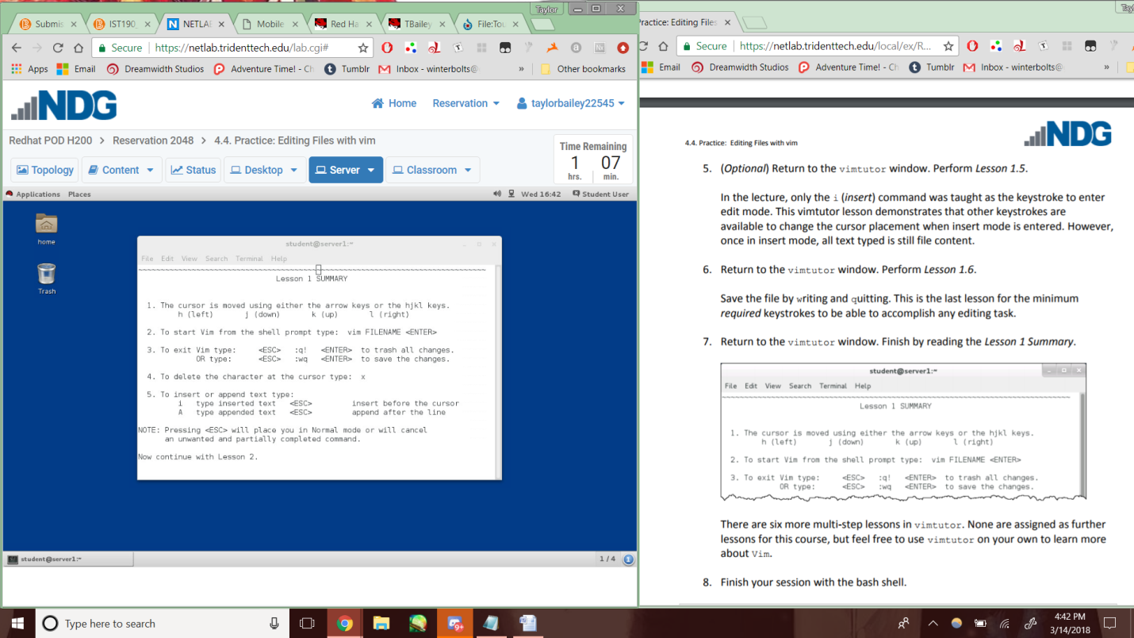

Lab2-4.6-6

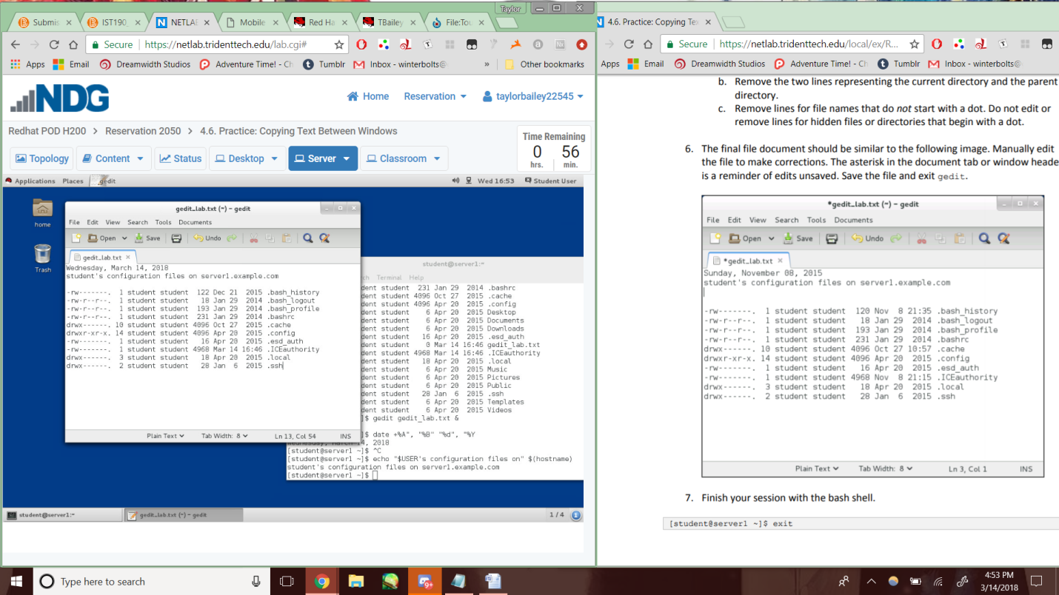

La2-4.7-13

